BOARD OF MANAGEMENT
Percentage of Programmes where syllabus revision was carried out during the last five years

Document Title
Minutes of Board of Management indicating the revision of syllabus & regulations and introduction of new programmes during the last five years




REGISTRAR
SECRETARY -BOARD OF MANAGEMENT



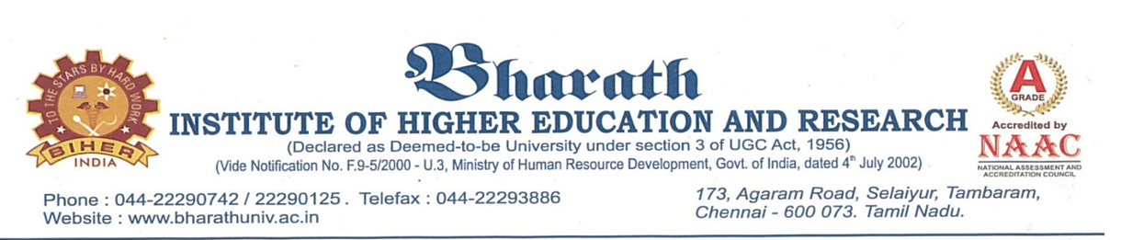
This is to certify that the following documents contain Minutes of Board of Management meetings along with agenda items and other activities performed during the last five years.
CONTENTS
SI.NO | Particulars | Board of Management Meeting No
1 | Board of Management Minutes _30.01.2018 | 57
2 | Board of Management Minutes _16.04.2018 | 58
3 | Board of Management Minutes _24.07.2018 | 59
4 | Board of Management Minutes _29.10.2018 | 60
5 | Board of Management Minutes _28.01.2019 | 61
6 | Board of Management Minutes _19.04.2019 | 62
7 | Board of Management Minutes _17.07.2019 | 63
8 | Board of Management Minutes _28.10.2019 | 64
9 | Board of Management Minutes _20.02.2020 | 65
10 | Board of Management Minutes _20.04.2020 | 66
11 | Board of Management Minutes _13.07.2020 | 67
12 | Board of Management Minutes _20.10.2020 | 68
13 | Board of Management Minutes _18.02.2021 | 69
14 | Board of Management Minutes _24.04.2021 | 70
15 | Board of Management Minutes _14.07.2021 | 71
16 | Board of Management Minutes _04.10.2021 | 72
17 | Board of Management Minutes _05.02.2022 | 73
18 | Board of Management Minutes _16.04.2022 | 74
19 | Board of Management Minutes _12.07.2022 | 75
20 | Board of Management Minutes _17.10.2022 | 76

REGISTRAR
SECRETARY -BOARD OF MANAGEMENT

